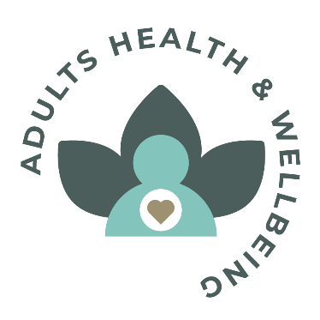

Adult Health and Wellbeing Network Agenda Monday 23rd March 2026

The proposed agenda is:

1)Introductions and apologies
2) IJB updates & highlights - Agenda for Argyll and Bute HSCP Integration Joint Board (IJB) on Wednesday, 25 March 2026, 1:00 pm - Argyll and Bute Council
3) Update on proposed budget cuts, and our voice matters work to date
4)General updates
5)AOCB

Date of next meeting Monday 25th May 2026 2PM

